Polymorphism

class Animal {

public void animalSound() {

System.out.println("The animal makes a sound");

}

}

class Pig extends Animal {

public void animalSound() {

System.out.println("The pig says: wee wee");

}

}

class Dog extends Animal {

public void animalSound() {

System.out.println("The dog says: bow wow");

}

}

class Main {

public static void main(String[] args) {

Animal myAnimal = new Animal();

Animal myPig = new Pig();

Animal myDog = new Dog();

myAnimal.animalSound();

myPig.animalSound();

myDog.animalSound();

}

}

Output:

The animal makes a sound  
The pig says: wee wee  
The dog says: bow wow

Example 2

class Polygon {

// method to render a shape

public void render() {

System.out.println("Rendering Polygon...");

}

}

class Square extends Polygon {

// renders Square

public void render() {

System.out.println("Rendering Square...");

}

}

class Circle extends Polygon {

// renders circle

public void render() {

System.out.println("Rendering Circle...");

}

}

class Main {

public static void main(String[] args) {

// create an object of Square

Square s1 = new Square();

s1.render();

// create an object of Circle

Circle c1 = new Circle();

c1.render();

}

}

Output

Rendering Square...

Rendering Circle...

Method overriding

//Java Program to demonstrate the real scenario of Java Method Overriding

//where three classes are overriding the method of a parent class.

//Creating a parent class.

**class** Bank{

**int** getRateOfInterest(){**return** 0;}

}

//Creating child classes.

**class** SBI **extends** Bank{

**int** getRateOfInterest(){**return** 8;}

}

**class** ICICI **extends** Bank{

**int** getRateOfInterest(){**return** 7;}

}

**class** AXIS **extends** Bank{

**int** getRateOfInterest(){**return** 9;}

}

//Test class to create objects and call the methods

**class** Test2{

**public** **static** **void** main(String args[]){

SBI s=**new** SBI();

ICICI i=**new** ICICI();

AXIS a=**new** AXIS();

System.out.println("SBI Rate of Interest: "+s.getRateOfInterest());

System.out.println("ICICI Rate of Interest: "+i.getRateOfInterest());

System.out.println("AXIS Rate of Interest: "+a.getRateOfInterest());

}

}

Output:

SBI Rate of Interest: 8

ICICI Rate of Interest: 7

AXIS Rate of Interest: 9

### Example 1: Polymorphism using method overriding

class Language {

public void displayInfo() {

System.out.println("Common English Language");

}

}

class Java extends Language {

@Override

public void displayInfo() {

System.out.println("Java Programming Language");

}

}

class Main {

public static void main(String[] args) {

// create an object of Java class

Java j1 = new Java();

j1.displayInfo();

// create an object of Language class

Language l1 = new Language();

l1.displayInfo();

}

}

**Output**:

Java Programming Language

Common English Language

Method Overloading: changing no. of arguments

**class** Adder{

**static** **int** add(**int** a,**int** b){**return** a+b;}

**static** **int** add(**int** a,**int** b,**int** c){**return** a+b+c;}

}

**class** TestOverloading1{

**public** **static** **void** main(String[] args){

System.out.println(Adder.add(11,11));

System.out.println(Adder.add(11,11,11));

}

}

Output:

22

33

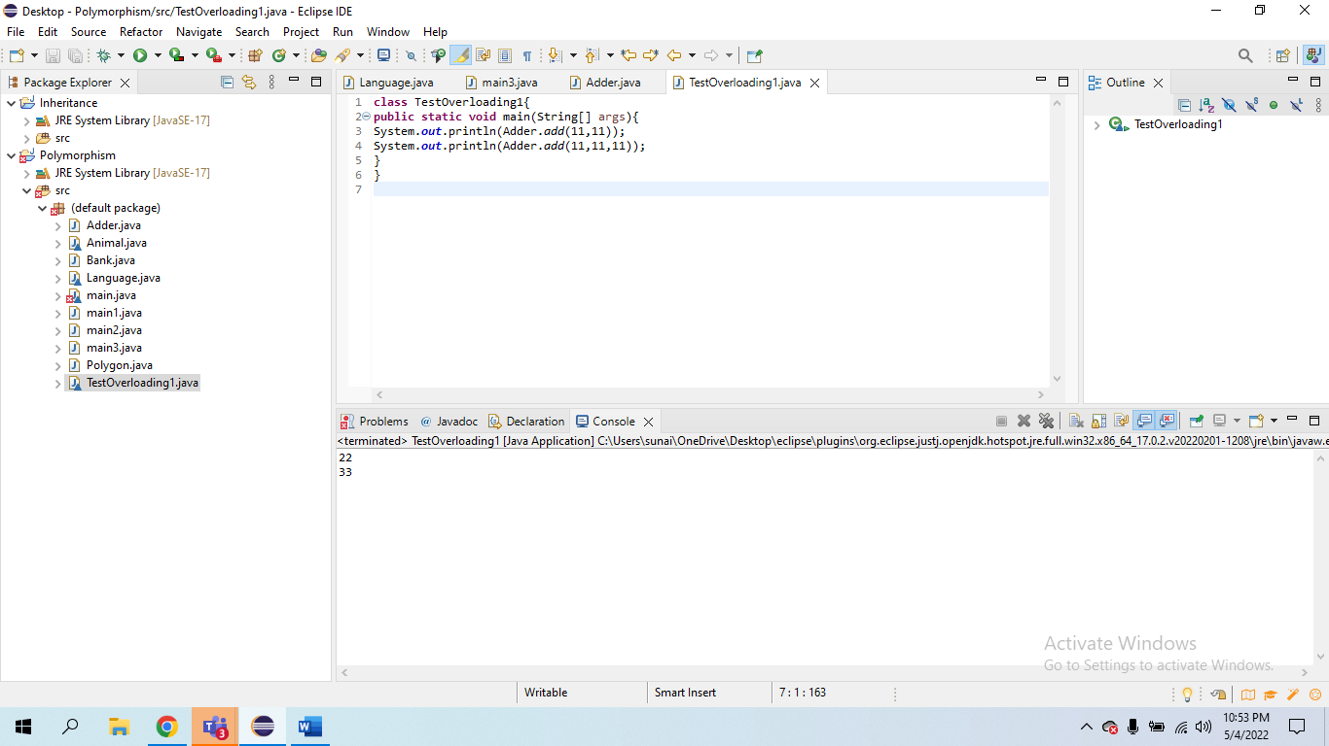

### 2) Method Overloading: changing data type of arguments

In this example, we have created two methods that differs in [data type](https://www.javatpoint.com/java-data-types). The first add method receives two integer arguments and second add method receives two double arguments.

**class** Adder{

**static** **int** add(**int** a, **int** b){**return** a+b;}

**static** **double** add(**double** a, **double** b){**return** a+b;}

}

**class** TestOverloading2{

**public** **static** **void** main(String[] args){

System.out.println(Adder.add(11,11));

System.out.println(Adder.add(12.3,12.6));

}

}

Output:

22

24.9

### Example 3: Polymorphism using method overloading

class Pattern {

// method without parameter

public void display() {

for (int i = 0; i < 10; i++) {

System.out.print("*");

}

}

// method with single parameter

public void display(char symbol) {

for (int i = 0; i < 10; i++) {

System.out.print(symbol);

}

}

}

class Main {

public static void main(String[] args) {

Pattern d1 = new Pattern();

// call method without any argument

d1.display();

System.out.println("\n");

// call method with a single argument

d1.display('#');

}

}

**Output**:

**********

##########

Simple Example of Encapsulation in Java

Let's see the simple example of encapsulation that has only one field with its setter and getter methods.

*File: Student.java*

//A Java class which is a fully encapsulated class.

//It has a private data member and getter and setter methods.

**package** com.javatpoint;

**public** **class** Student{

//private data member

**private** String name;

//getter method for name

**public** String getName(){

**return** name;

}

//setter method for name

**public** **void** setName(String name){

**this**.name=name

}

}

*File: Test.java*

//A Java class to test the encapsulated class.

**package** com.javatpoint;

**class** Test{

**public** **static** **void** main(String[] args){

//creating instance of the encapsulated class

Student s=**new** Student();

//setting value in the name member

s.setName("vijay");

//getting value of the name member

System.out.println(s.getName());

}

}

Compile By: javac -d . Test.java

Run By: java com.javatpoint.Test

Output:

vijay

Read-Only class

//A Java class which has only getter methods.

**public** **class** Student{

//private data member

**private** String college="AKG";

//getter method for college

**public** String getCollege(){

**return** college;

}

}

Now, you can't change the value of the college data member which is "AKG".

s.setCollege("KITE");//will render compile time error

Write-Only class

//A Java class which has only setter methods.

**public** **class** Student{

//private data member

**private** String college;

//getter method for college

**public** **void** setCollege(String college){

**this**.college=college;

}

}

Now, you can't get the value of the college, you can only change the value of college data member.

System.out.println(s.getCollege());//Compile Time Error, because there is no such method

System.out.println(s.college);//Compile Time Error, because the college data member is private.

//So, it can't be accessed from outside the class

Another Example of Encapsulation in Java

Let's see another example of encapsulation that has only four fields with its setter and getter methods.

*File: Account.java*

//A Account class which is a fully encapsulated class.

//It has a private data member and getter and setter methods.

**class** Account {

//private data members

**private** **long** acc_no;

**private** String name,email;

**private** **float** amount;

//public getter and setter methods

**public** **long** getAcc_no() {

**return** acc_no;

}

**public** **void** setAcc_no(**long** acc_no) {

**this**.acc_no = acc_no;

}

**public** String getName() {

**return** name;

}

**public** **void** setName(String name) {

**this**.name = name;

}

**public** String getEmail() {

**return** email;

}

**public** **void** setEmail(String email) {

**this**.email = email;

}

**public** **float** getAmount() {

**return** amount;

}

**public** **void** setAmount(**float** amount) {

**this**.amount = amount;

}

}

*File: TestAccount.java*

//A Java class to test the encapsulated class Account.

**public** **class** TestEncapsulation {

**public** **static** **void** main(String[] args) {

    //creating instance of Account class

    Account acc=**new** Account();

    //setting values through setter methods

    acc.setAcc_no(7560504000L);

    acc.setName("Sonoo Jaiswal");

    acc.setEmail("sonoojaiswal@javatpoint.com");

    acc.setAmount(500000f);

    //getting values through getter methods

    System.out.println(acc.getAcc_no()+" "+acc.getName()+" "+acc.getEmail()+" "+acc.getAmount());

}

}

Output:

7560504000 Sonoo Jaiswal sonoojaiswal@javatpoint.com 500000.0

